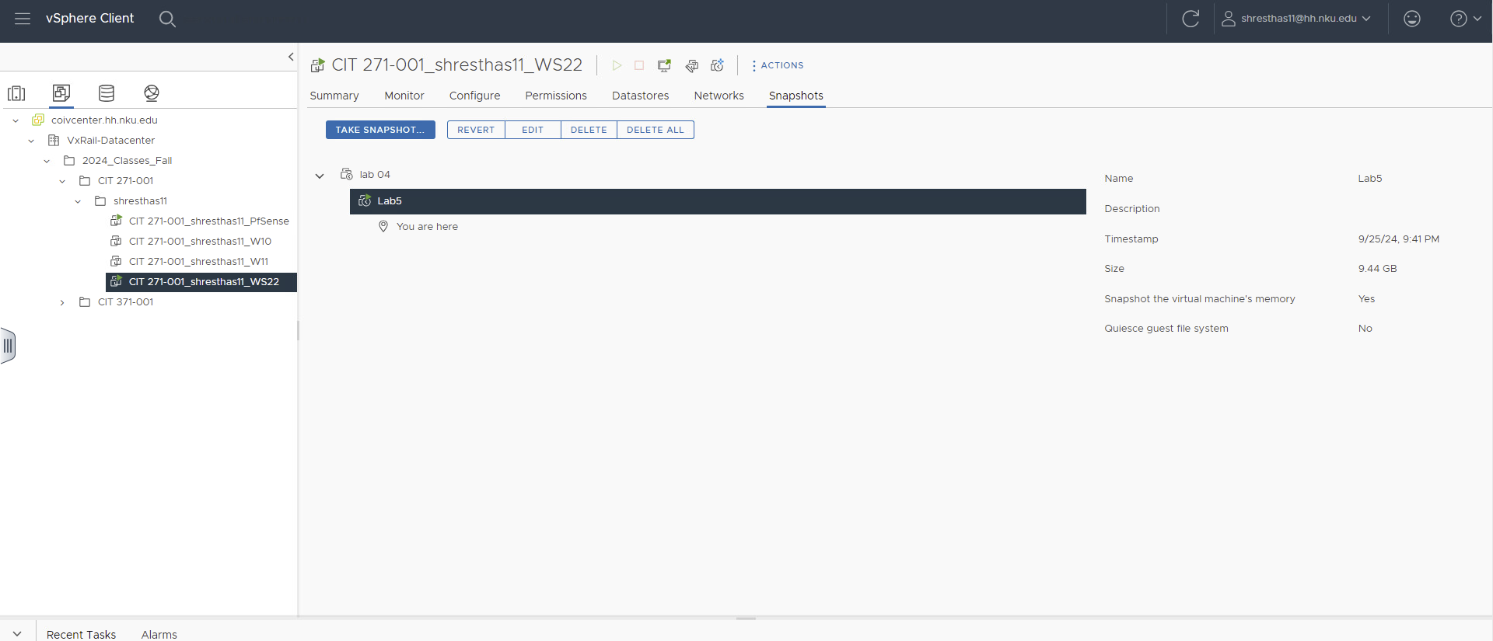
New-ADOrganizationalUnit -Name "Facilities" -Path "OU=Departments,DC=cit271,DC=com"

New-ADGroup -Name "Facilities Users" -SamAccountName "Facilities Users" -GroupCategory Security -GroupScope Global -DisplayName "Facilities Users" -Path "OU=Groups,DC=cit271,DC=com"
ConvertTo-SecureString "Student271!" -AsPlainText -Force

New-ADUser -Name "Mario McMario" -GivenName "Mario" -Surname "McMario" -SamAccountName "mcmario1" -UserPrincipalName "mcmario1@cit271.com" -Path "OU=Facilities,OU=Departments,DC=cit271,DC=com" -AccountPassword (ConvertTo-SecureString -AsPlainText "Student271!" -Force) -Enabled $true

New-ADUser -Name "Mowz McMowz" -GivenName "Mowz" -Surname "McMowz" -SamAccountName "mcmowz1" -UserPrincipalName "mcmowz1@cit271.com" -Path "OU=Facilities,OU=Departments,DC=cit271,DC=com" -AccountPassword (ConvertTo-SecureString -AsPlainText "Student271!" -Force) -Enabled $true

Add-ADGroupMember -Identity "Facilities Users" -Members mcmario1,mcmowz1
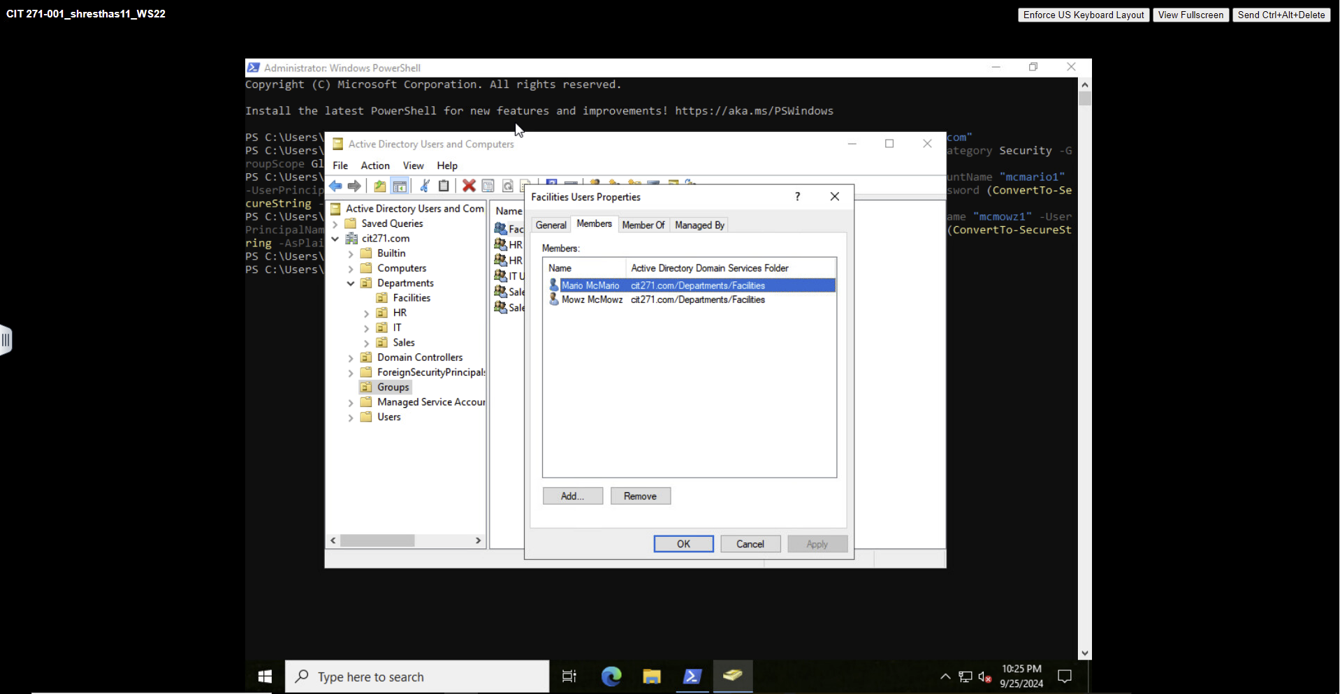

Get-Service | Where-Object {$_.Status -eq "Running"} | Sort-Object -Property DisplayName | Select-Object -Property Status, DisplayName, StartType | Export-Csv -Path C:\services.csv -NoTypeInformation

